Instruction how to send Rubles from **Rosselhozbank** to NIIB

*Through mobile application of NIIB*

1. Log in to application of NIIB using your username and the password

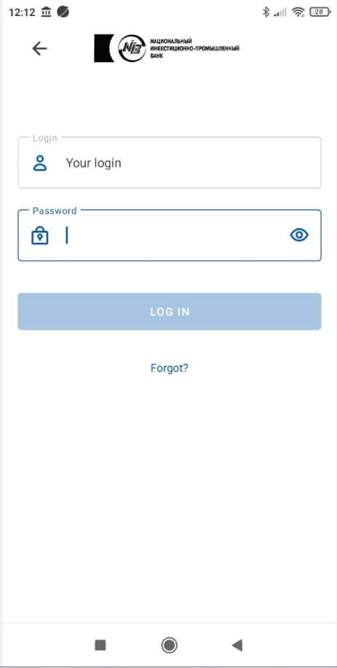

1. To request the transfer of funds from another bank, select the **Payment** tab on the main page

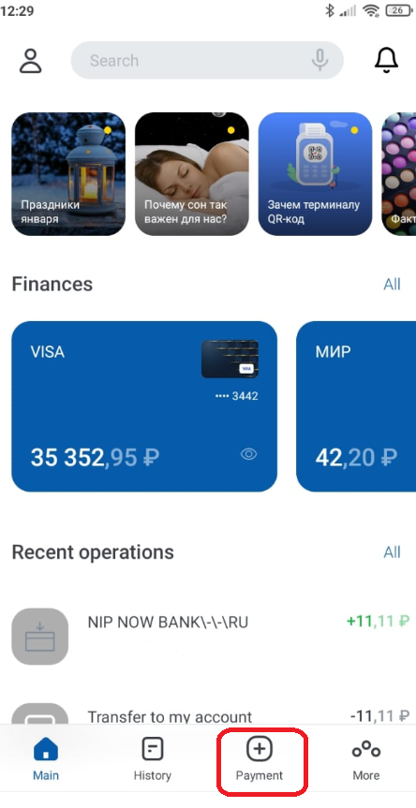

1. Next, select **Account replenishment by FPS**

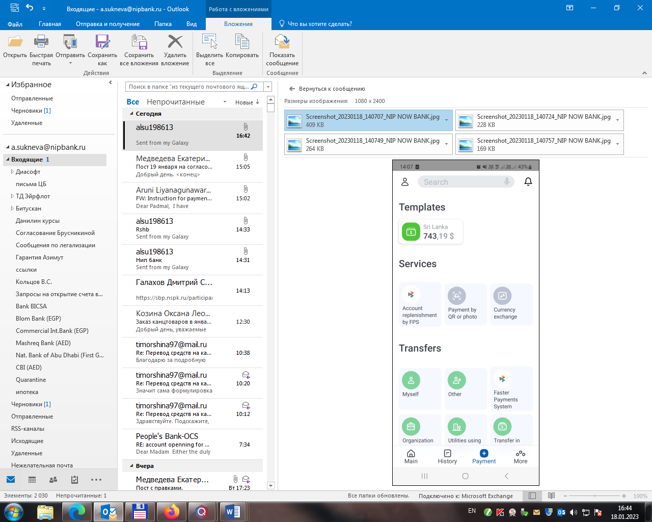

1. Next, select the bank from where to transfer the funds

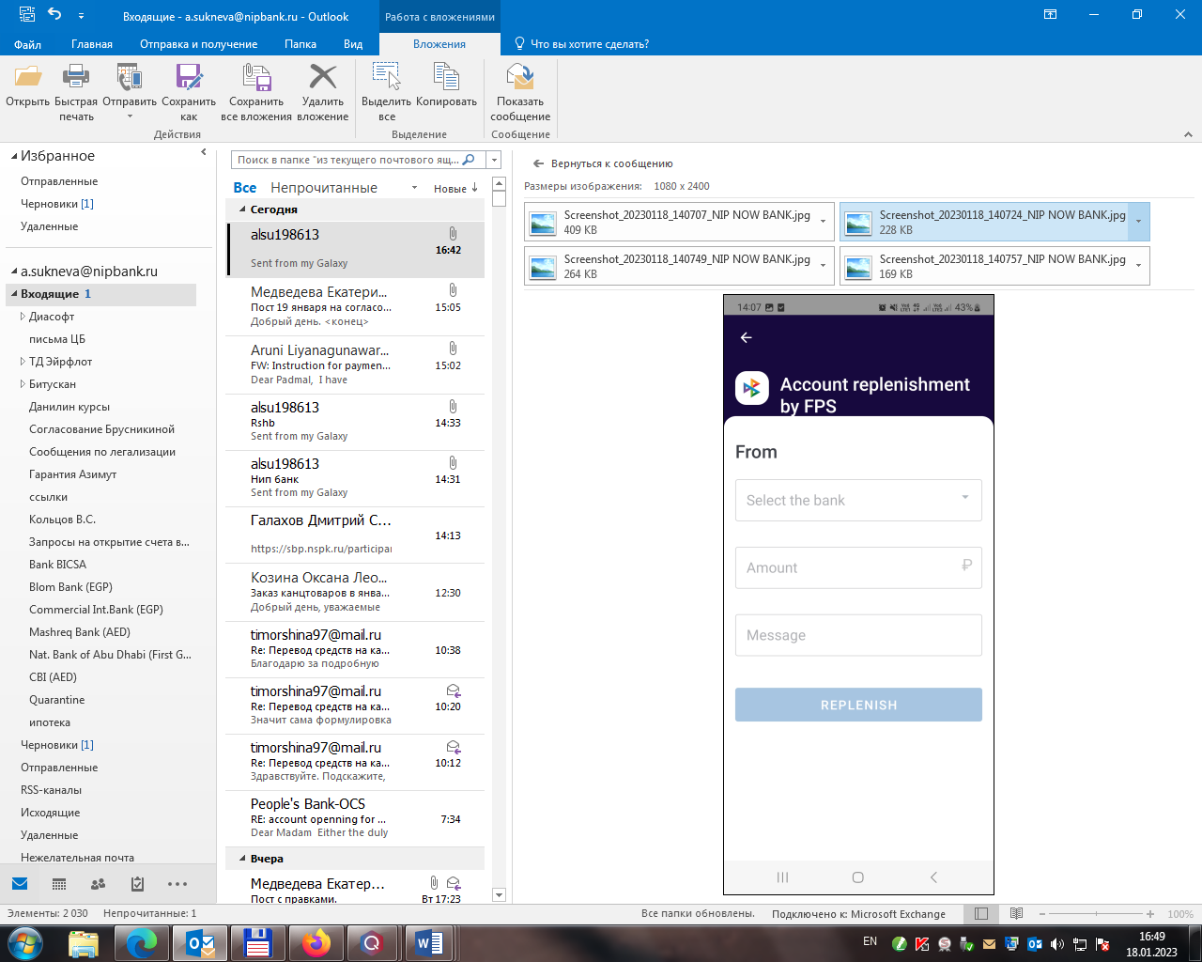

You need to select Rosselhozbank (fill in the name in Russian), the amount in rubles and message (if necessary). Then press REPLENISH button.

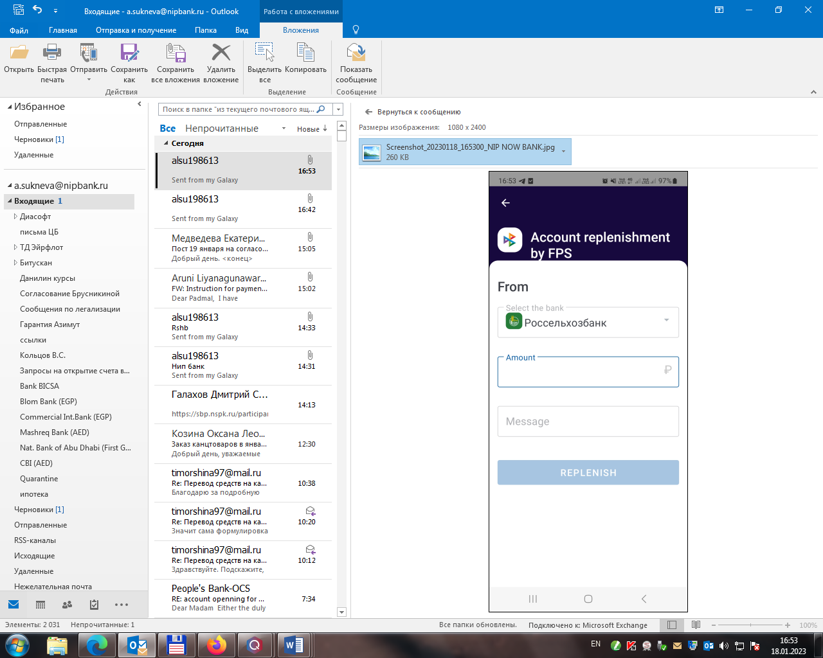

1. The request will be sent to Rosselhozbank

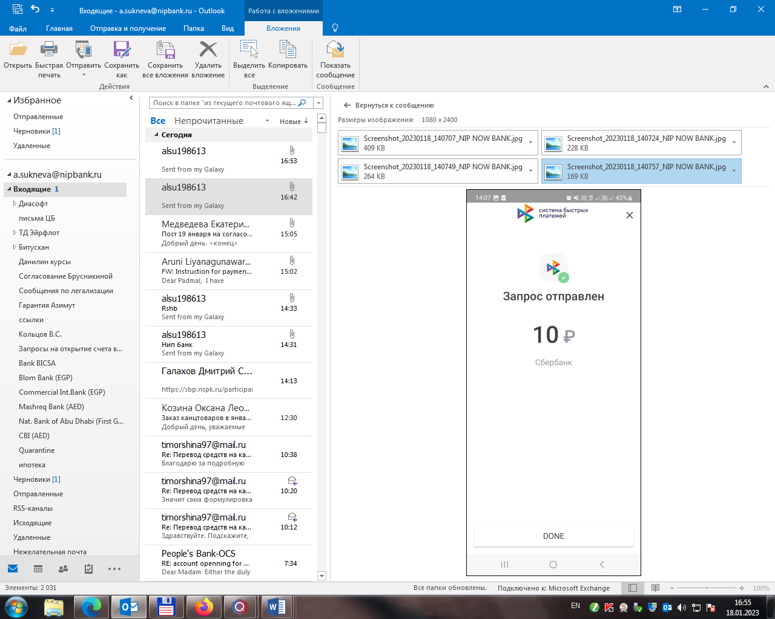

1. Next, you need to log in to your mobile application with Rosselhozbank and confirm the request for payment. If you missed the message, you can find it under the sign of the bell.

